**Introduction**

Aim of the project is to build an electronic buggy, which can autonomously follow a white line around a track, which consists of sharp turns and a slope (that has an angle of less than 18 degrees). For our buggy to go up the ramp it will require more torque, therefore we need something which will change the torque and speed of the buggy, depending on the situation, e.g. moving up the ramp or on a flat surface. To achieve this our buggy requires a gearbox. Using a gearbox has advantages but also some disadvantages:

Advantages

* It can change the torque, depending on the load, on the motor.
* It can be used to increase and reduce the speed.
* Provides large variety of torque and speed with same input power.

Disadvantages:

* Results in lower overall efficiency due to additional components. E.g. energy lost due to friction between gear wheels.
* Additional cost of a gearbox.
* Maintenance of the gearbox. E.g. lubricating the teeth, for better functionality.

We have three options of gearboxes to choose from, and to choose the best gearbox for our buggy we have done various experiments and calculation, which are discussed later in the report.

The buggy uses DC motors, which are controlled by changing the voltage applied to the terminals. The most efficient way of powering the motor is using digital switches, which are used to produce analogue voltage output. This is done using motor drive board. An example output from the motor drive voltage waveform is shown below.

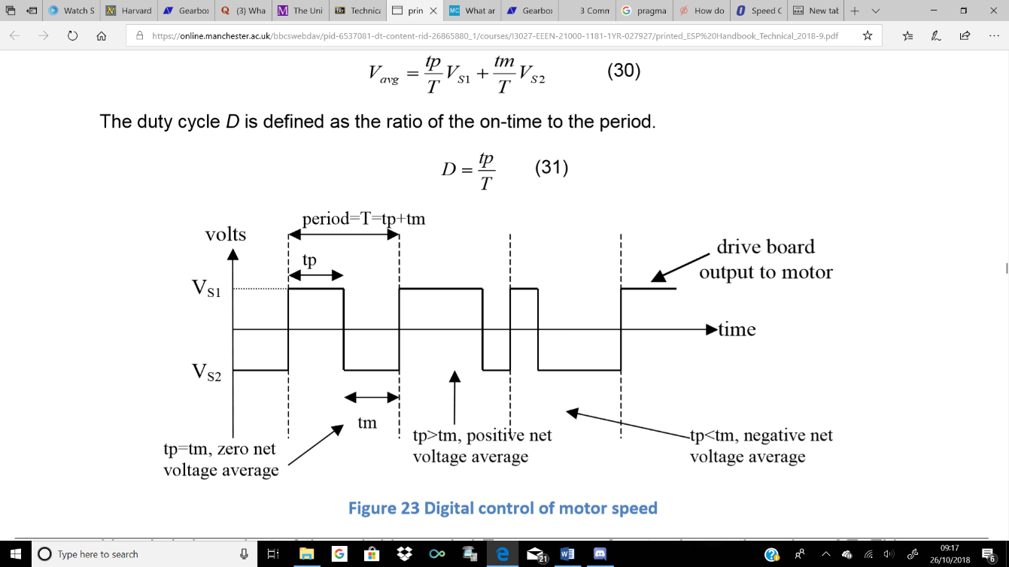

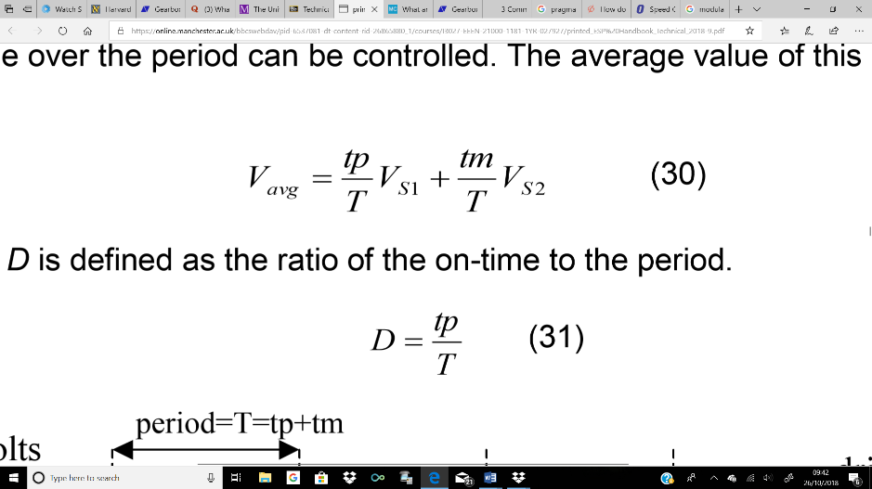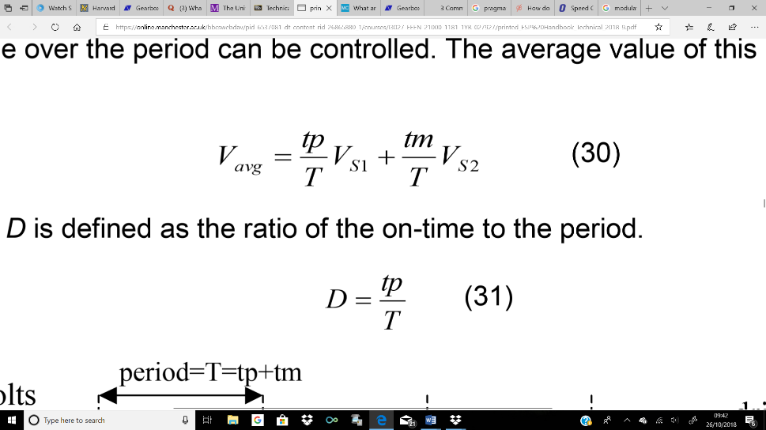If the voltage is switched between VS1 and VS2, and the ratio of on-time (time in higher voltage state, tp) to period (tp+tm) is modified, average voltage over the period can be controlled by changing the on-time. Voltage average of this pulse is given by equation (1) and the ratio of on-time to period (Duty cycle D) is given by equation (2).

eq. (1) eq. (2)

Motor drive board has switches arranged in a “H” pattern and bipolar and unipolar are two ways in which H-bridge switch pattern operate. In bipolar mode all 4 switches are used and there is constant switching between the full battery voltage in one direction and full battery voltage in the other. In unipolar 2 switches are changing states between battery voltage and 0V.

Microcontroller is used to control the motor drive board. PWM signals (Pulse width modulation) are sent to the motor drive board by microcontroller to control the speed of motor. It also sends a digital signal, to motor drive board, to select bridge control mode (bipolar, unipolar), and if unipolar, then the direction of movement is sent, using another digital output pin.